# Meeting Summary Realistic Expectations, Confirmation of Ideas and Specification:

**Date:** 12/02.24

**Participants:**

* Member 1 (Dylan Carter - 720007761 - [dc713@exeter.ac.uk](mailto:dc713@exeter.ac.uk))
* Member 2 (Jamie Elder - 720011935 - [je497@exeter.ac.uk](mailto:je497@exeter.ac.uk))
* Member 3 (Victor Smith - 720087895 - [vphs201@exeter.ac.uk](mailto:vphs201@exeter.ac.uk))
* Member 4 (Daniel Hart - 700046191 - [dh590@exeter.ac.uk](mailto:dh590@exeter.ac.uk))
* Module Lead (Solomon Oyelere – [s.oyelere@exeter.ac.uk](mailto:s.oyelere@exeter.ac.uk))

**Session** **Lasted:** 45 minutes.

## Objective:

In this meeting, we met with the module lead and confirmed if our ideas matched the criteria set for us properly and if our expectations were achievable in the time we had. Also to receive any other information we may need to fully complete the Project Specification.

## Discussion Points:

### Confirmation of Ideas

At this meeting, we met with the module lead and confirmed if our ideas matched the criteria set for us properly and if our expectations were achievable in the time we had. Firstly, we approached him with the idea for our app, how it included location and how it affects sustainability on campus. After hearing our ideas, he was pleased with what we came up with, however, he told us to be mindful of our workload and to avoid doing too much for our first sprint. Also, we talked to him about our future ideas of what our app could be, and he was happy with the extent to which the application could be built upon, even describing that our application could be a whole ‘business’. With this backing from the module lead, we properly discussed our ambitions for this sprint and project.

### Ambitions for Project

Our full ambitions for the project are to be an app where you log in and everyone who logs in on that day gets given the same word to guess, after getting the word after so many tries you get a score which you can compare to all your previous attempts at the word and you would get the score added to your ‘Foodle’ score that would be linked to your account. After this you can scan a QR code and join the group that is linked to the QR code. When in a group you can leave said group to join another group or you can be involved in the groups planned meals. You can plan a meal by selecting a recipe that is on the recipes page and selecting said recipe for as many people as you are planning to cook for. You would also be able to create recipes on a specified page which would allow you to search through a database full of ingredients and add them to the recipe, also allowing you to write the preparation for said recipe, state how many people the recipe is supposed to be for, name of the recipe and how long the recipe would take to prepare. When you create a recipe, it would automatically be given an eco-score based on the ingredients used. This score would increase the score of a user each time they used the recipe. Then all the scores given would be in their own leaderboards ranking every user and as well as possible ranking accommodations also.

### Achievable Goals and Tasks

We believed that our base idea of having a log-in, playing a game, joining a group through a QR code, choosing a recipe, creating a recipe, organising a cook and getting scores for the recipes and game was achievable enough in time frame given and we could start with the design of the databases and pages. So, we decided to allocate the design of the databases and pages to Victor as he is the most adept with databases and all the pages would rely on the databases to function. After this discussion we went through the specification again and started setting up the basics for our project. We needed to create a Kanban Board and a GitHub repository, and Daniel was given the role of making both of those. As this project required the use of Django, Jamie was tasked with setting up the Django framework needed for us to get our project underway. All these tasks were what we believed to be required for us to start our project.

## Conclusion:

After this meeting we are excited with our idea and happy that we have realistic goals that we can achieve in this sprint, we are also excited to build more on our idea in the future as we believe this application could have an endless number of features that would promote the three main points of gamification, on campus sustainability and location. We are also happy with the roles we have been given because they accentuate our strengths and make our project seem sturdy and unlikely to fail.

## Next Steps:

1. Creation of ‘Foodle’ code
2. Creation of scanning and creating QR codes
3. Start of Django page models
4. Development of Databases

## Action Items:

1. Creation of GitHub
2. Creation of Kanban
3. Creation of Django framework
4. Creation of pages and database design

# Meeting Related Images

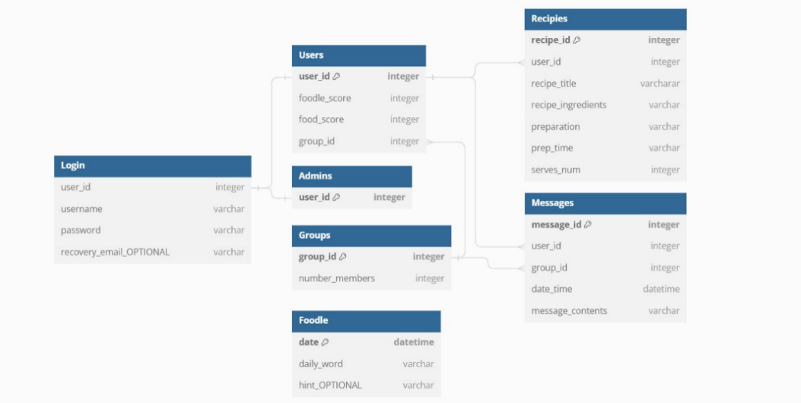

Above First Database Design

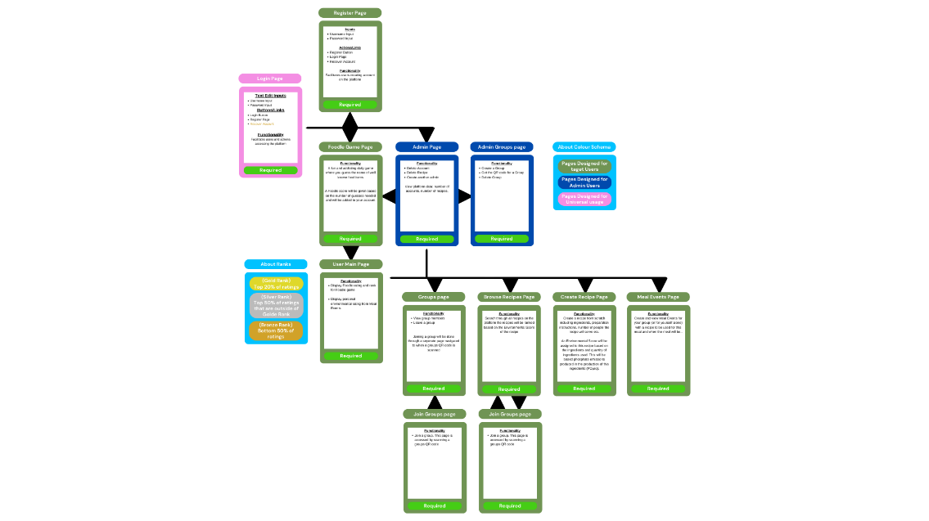Above Starting Kanban Board

Above Pages design